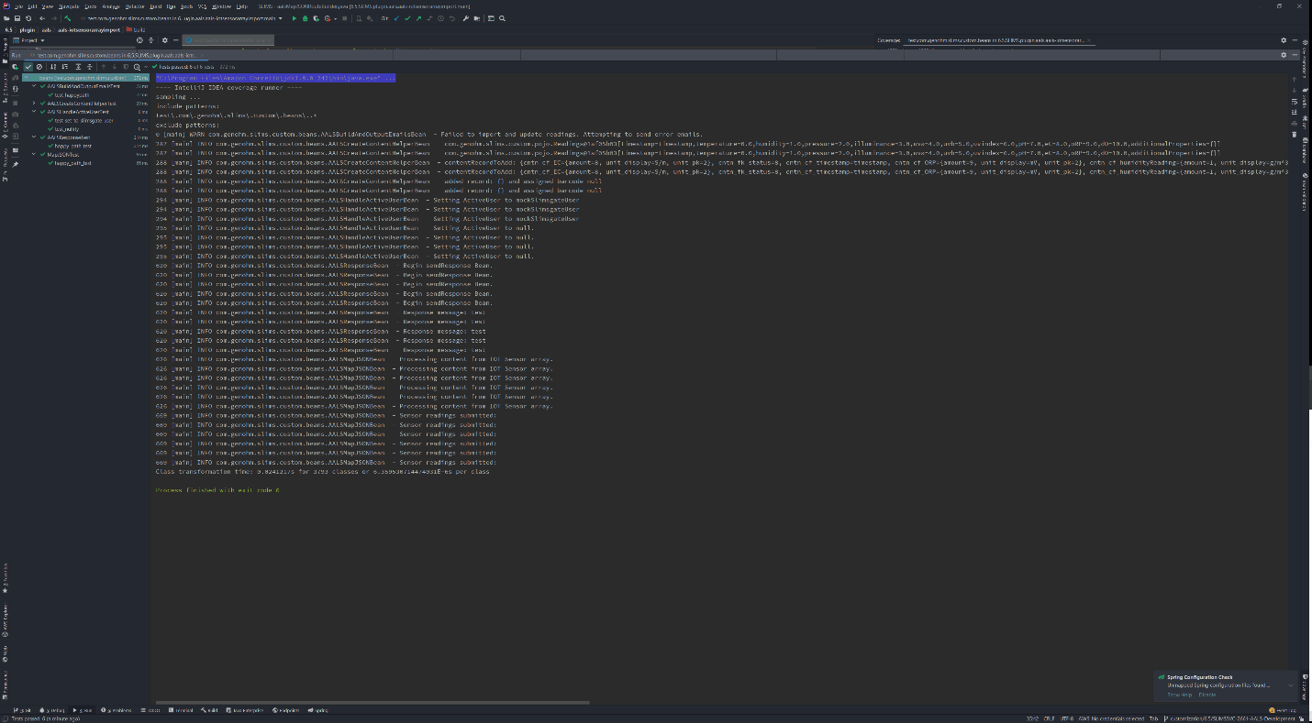
Testing the AALS
In phase one of development, Junit testing was utilized to address happy path patterns of system processes for the AALS Slimsgate plugin. Unit tests were written solely for the beans designated as handlers. In this testing approach, the AAA testing pattern was implemented. The test suite for the plugin was arranged, acted upon, and an assertion evaluated an expected result against an actual result. Testing was automated with each commit and used to help identify build success during the continuous integration process. Unit testing guidelines were driven during the development of test cases. As an example, meaningful test names were devised by adding the subscript test to the existing name of the handler. In addition, each test within the suite was designed to run independently and intended to test each individual feature implemented within the plugin.

